- Purpose
  - The purpose of this document is to describe the procedure for assembling an Optima Propane Burnisher without emissions.
- Scope
  - This SOP applies to all equipment assembly team members. The process applies to the following machines:
E012800EQM0600BE1200 – 21” Optima XR
E012805EQM0600BE1200 – 21” Optima XR w/ Clutch
E012830EQM0600BE1200 – 27” Optima XR
E012835EQM0600BE1200 – 27” Optima XR w/ Clutch
E012850EQM0600BE1200 – 27” Optima XR w/ Dust Control
E012860EQM0600BE1200 – 27” Optima XR w/ Clutch & Dust Control
- Responsibilities
  - The operations manager/supervisor is responsible for enforcing this SOP.
- Materials
  - The proper materials needed for this process are listed on the machine work order.
  - Hand/Power Tools
- Definitions

- Procedure
  - Start by assembling an Optima Propane Burnisher Deck per SOP EQ 072.
  - Assemble the motor per SOP EQ 027.
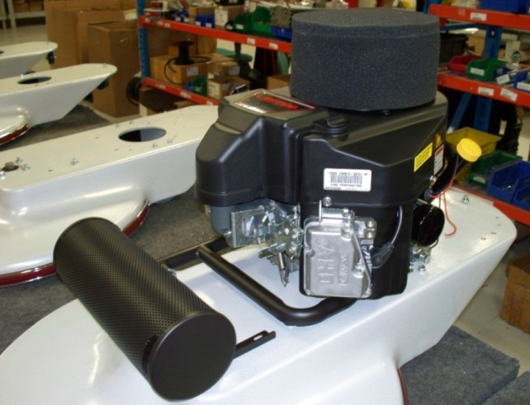
  - Place the deck so that the wheels are on the table. Put 4 spacers (E80130) over the mounting holes for the engine. Place the completed engine on the deck with the output shaft going through the large hole.

  - Bolt the motor to the deck from the bottom using 4 bolts (87644) and 4 lock washers (81066) and 4 spacers (80130). Tighten the back 2 bolts with a 9/16” socket.
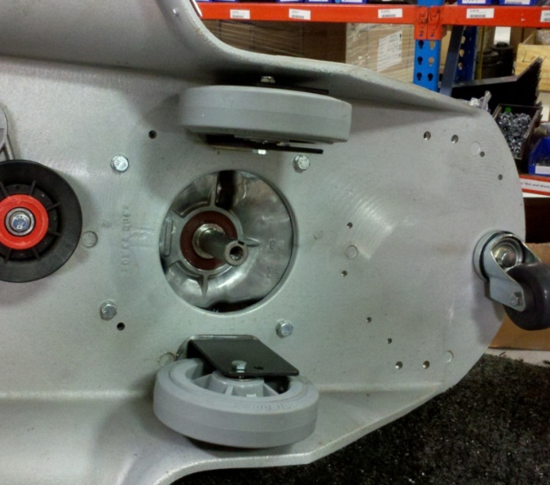

  - Flip the machine on its side as shown above to gain access to the bottom of the deck. Tighten the front 2 bolts.
  - If the machine is to be equipped with a clutch, proceed to step 6.07. If the machine will not have a clutch, advance to step 6.14.
  - Get a centrifugal clutch (89768) and remove the set screw from the collar on it.

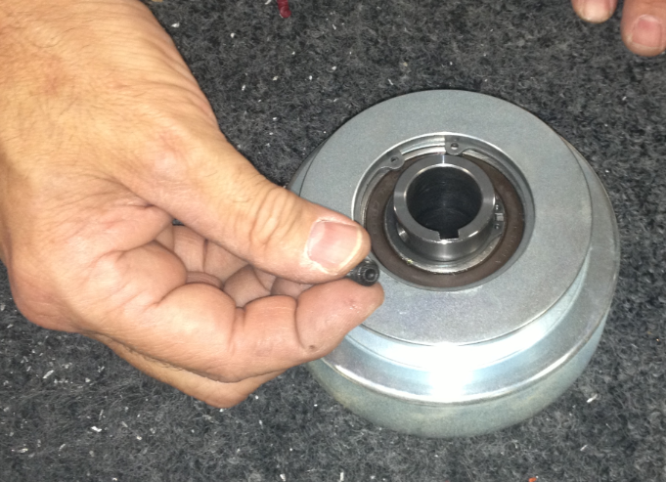

  - Place the top clutch spacer (86122) over the end of the motor shaft as shown.

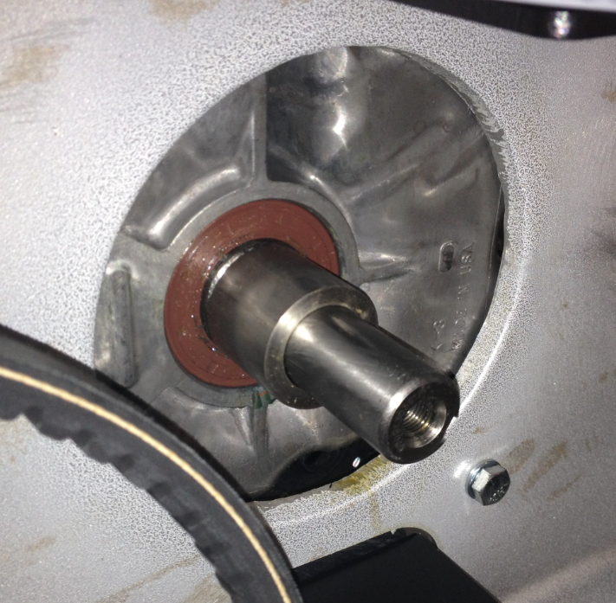
  - Place the clutch onto the shaft in the orientation shown.

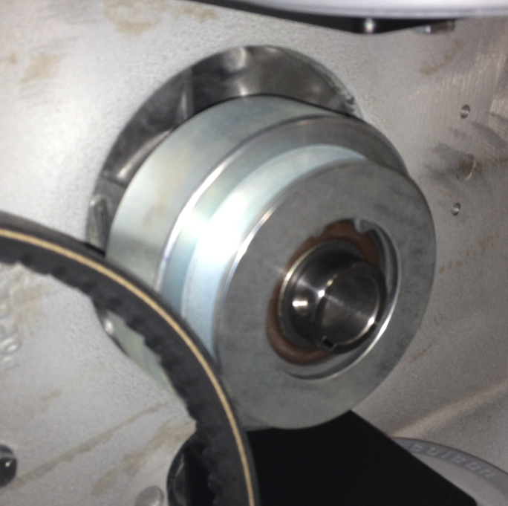

  - Align the keyways on the motor shaft and the clutch. Once this is done, slide a key (11289) into the keyway.

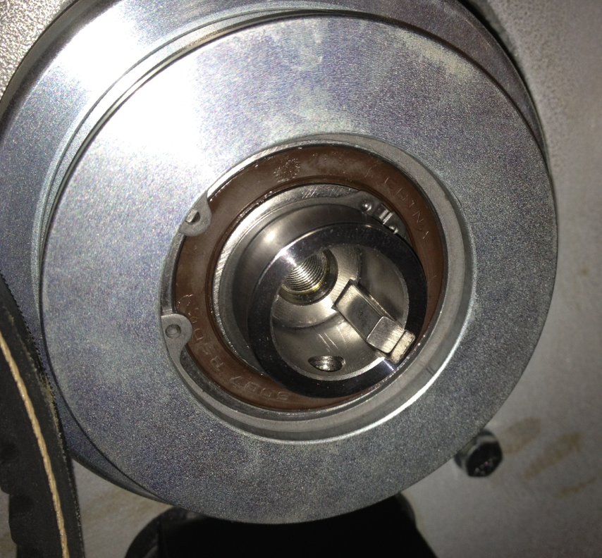

  - Place the bottom clutch spacer (86229) into the location shown.

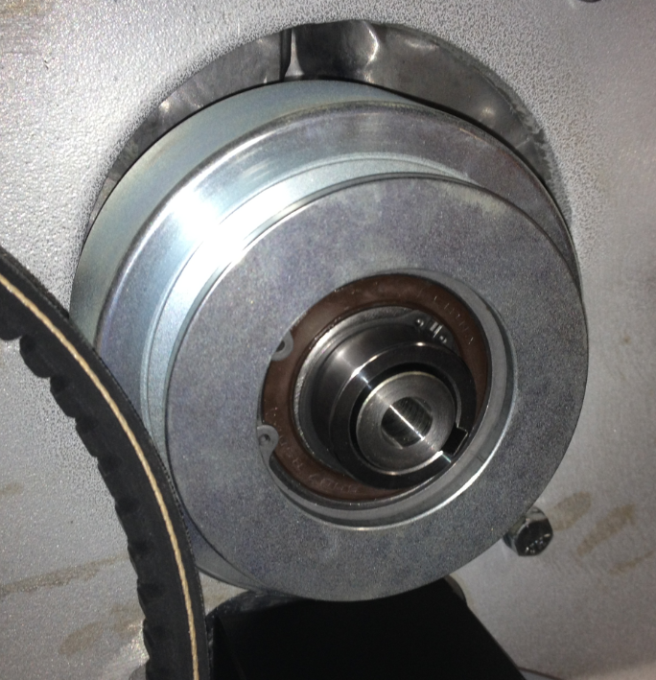
  - Fasten the clutch onto the engine shaft using a bolt (10598), a lock washer (10117), a flat washer (12447), and another flat washer (11501). Put some blue Loctite onto the bolt threads before installing.

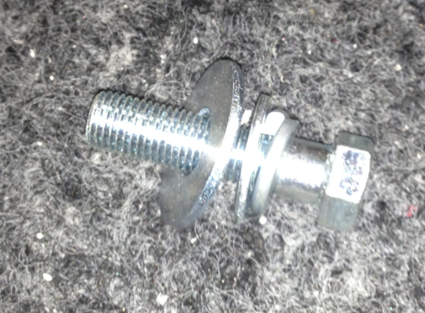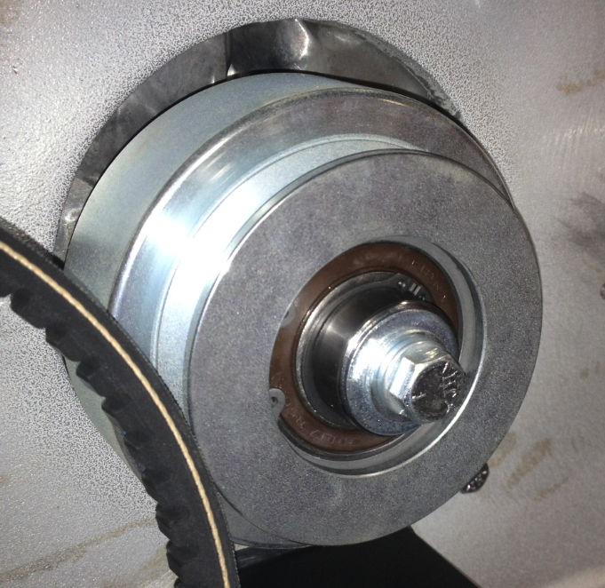

  - Proceed to step 6.16. NOTE: Many of the photos after this will show the standard pulley on the motor shaft rather than the clutch.
  - Get a drive pulley that was assembled per SOP EQ 074. Slide the pulley assembly onto the motor shaft in the orientation shown. Be sure to line the keyway up. Install the key (11289). You may need to tap it with a hammer to get it all the way in.
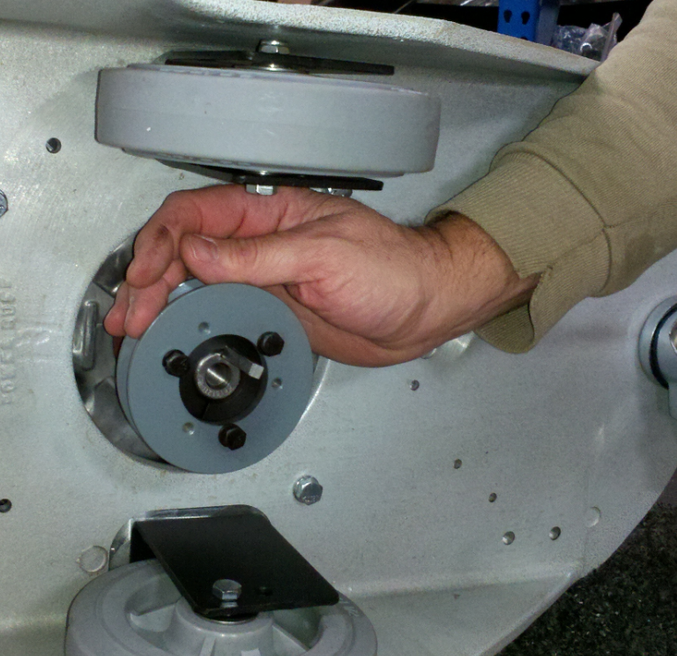
Pulley
Key
Bushing

  - Tighten the screws on the bushing with a 7/16” socket. Do not tighten each one individually all the way. Alternate back and forth tightening each one little by little. This will ensure that the assembly does not bind. Verify the the pulley is centered on the belt so that it does not cause any uneven wear. Loosen the screws and move the pulley if needed. Once that is complete, tighten the set screw that is located on the collar of the bushing. Tighten set screw.

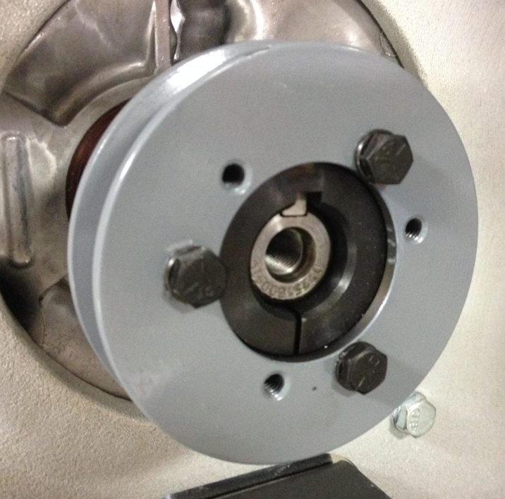

  - Install the belt around the pulleys. For a 27” machine use 12979 and 12978 for a 21” machine. This step may be difficult. You may need to spin one of the pulleys to get the belt stretched around and properly seated.
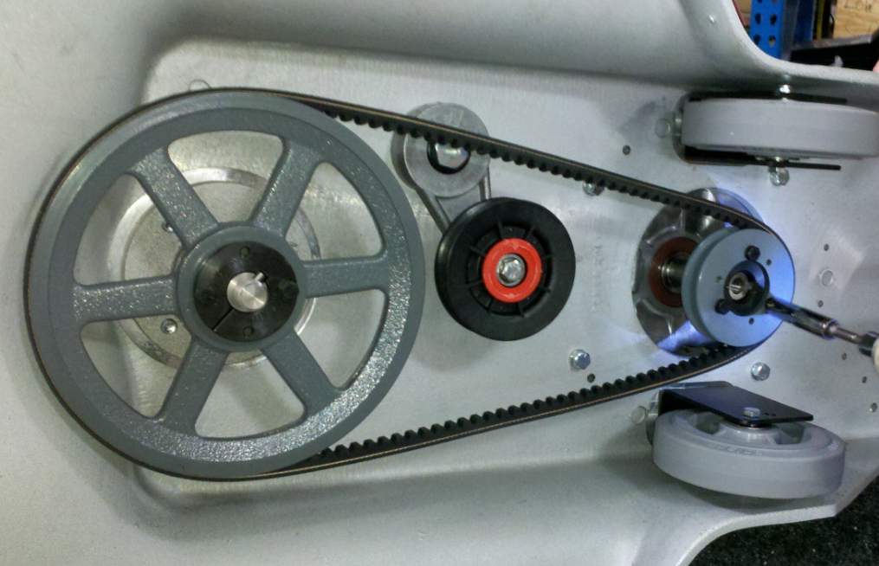

  - Using a long handled socket wrench, tighten the tensioner pulley. Use the socket wrench to rotate the pulley until the desired amount of tension is reached. Use the photo below as a reference. On the top side of the deck, tighten the bolt that was put into place finger tight earlier.
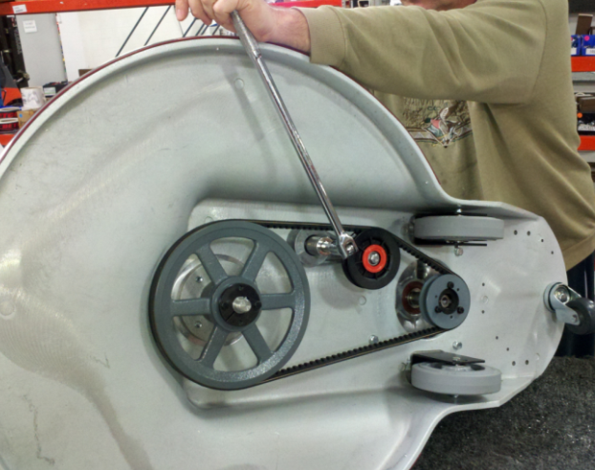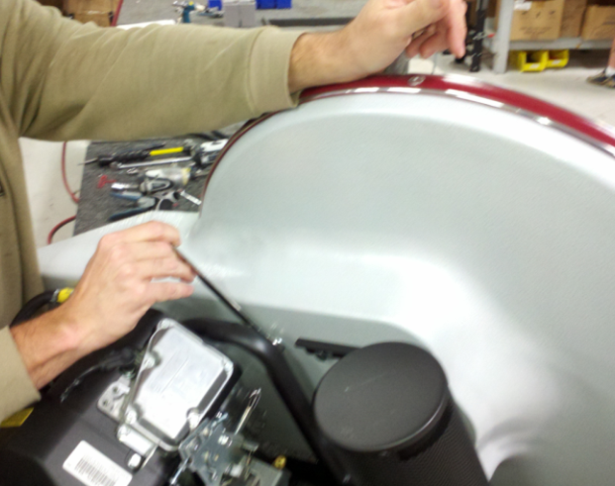

  - For a 27” machine, place 1 washer (11135) over the threads on the center pulley shaft place anti-seize on the threads. This will shim the pad driver to the correct location. For a 21” machine, no washer is needed (Still use anti-seize).
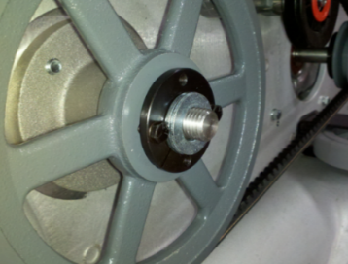

  - Select the appropriate size pad driver for the machine being built. Refer to SOP EQ 024 for instructions on how to build. Put some anti-seize compound on the threads of the pad driver. Thread the pad driver onto the spindle. Keep in mind that the spindle has left handed threads. Add the pad installation here.
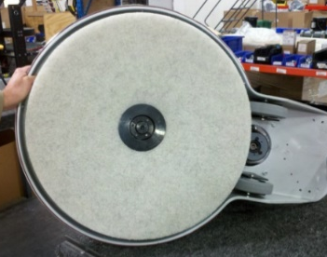

  - At this point, flip the machine back onto its wheels so that the wiring can be completed.
  - Below is the picture of the wiring harness (80135) and where the different wires and connections are used. Verify that the correct wire is being used in each step below. Emissions harness is (80140).

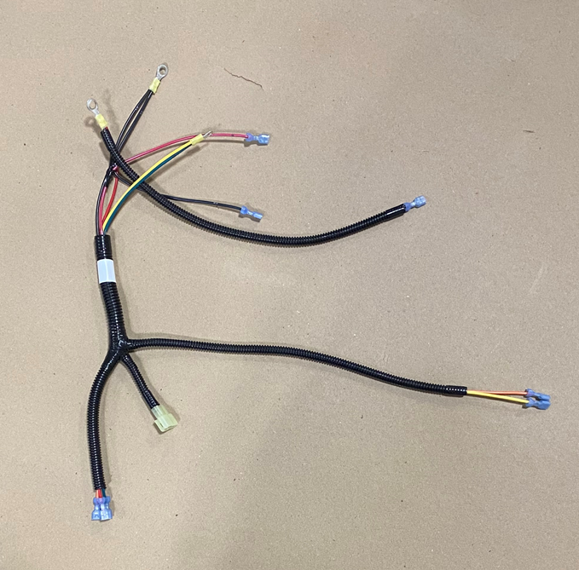
Used at oil pressure switch
Used at fuel shutoff
Used at key switch
Used at voltage regulator
Used at hour meter
Used at engine and solenoid
Used for engine ground
Used for back of solenoid

Used on solenoid

  - Start the wiring with a solenoid (11772) and a wiring harness. Connect the ring terminal that has the yellow and green wires to the appropriate terminal on the solenoid. Finger tighten a nut (10120) to hold the wires in place with a 10mm nut driver.
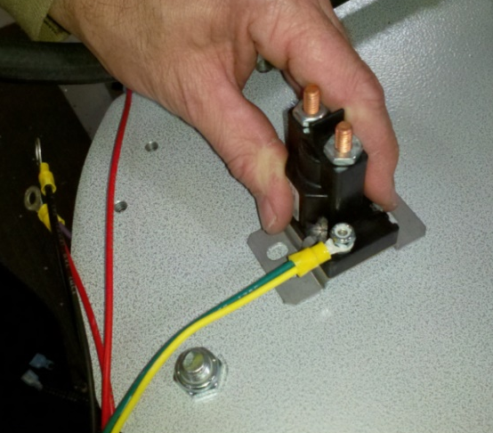

  - Move the solenoid to its proper location on the machine deck. See the photo below for orientation. Lay the wiring harness in the direction shown.
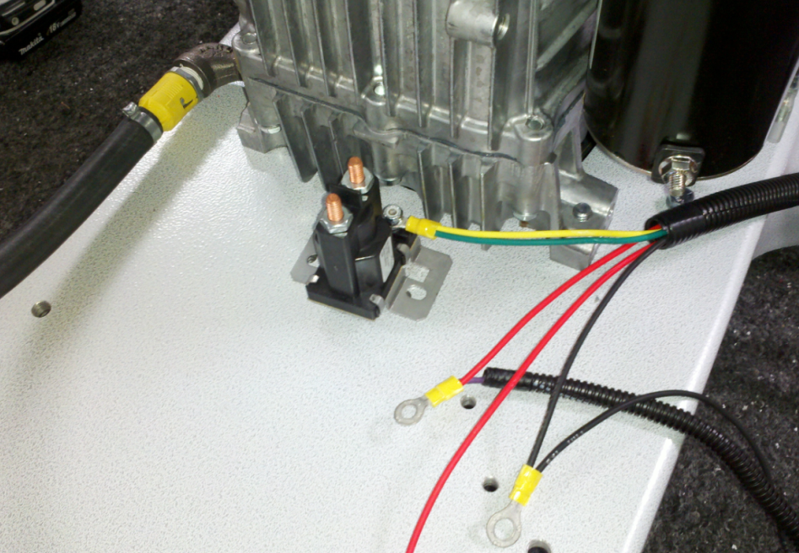

  - Use 2 bolts (10122) and 2 nuts (83520) to attach the solenoid to the deck (7/16” socket). Install a black cable (12381) onto the side of the solenoid shown. Note the orientation of the cable. Tighten all of the nuts on the solenoid (3 locations).
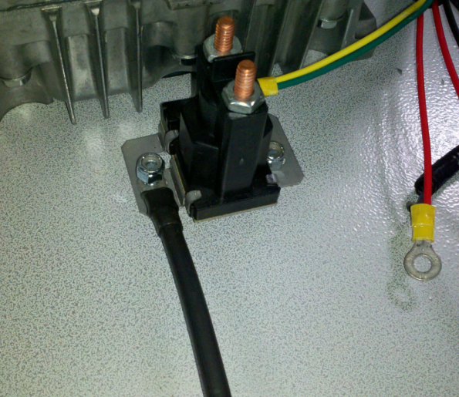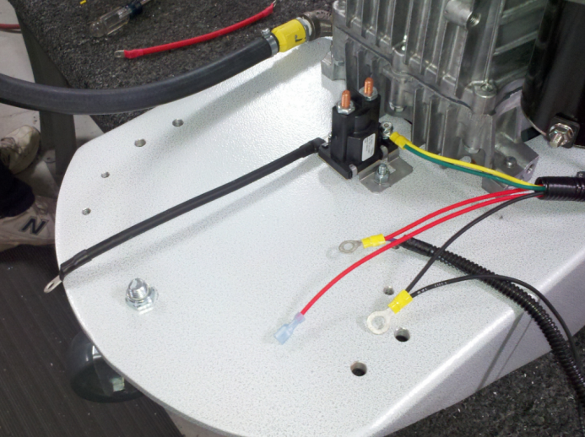

  - On the wiring harness there is a ring terminal with a red and a purple wire. Place the ring terminal over the solenoid post shown in the photo. The purple wire with the loom connects to the voltage regulator on the motor. Run the wire behind the starter to keep it from getting snagged during use.
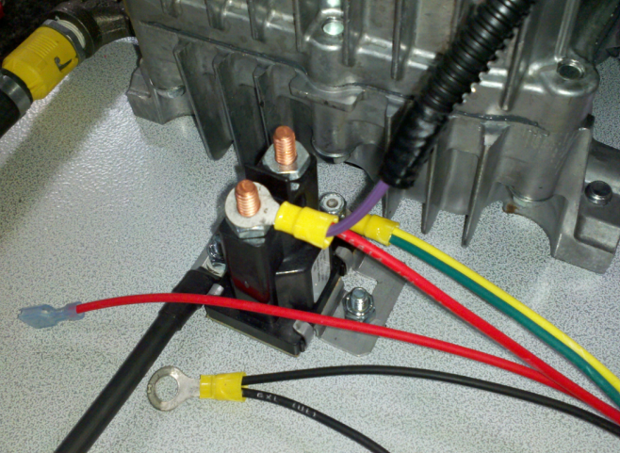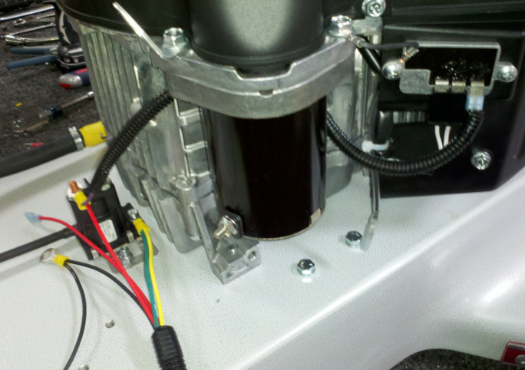
Purple Wire (inside loom)
Voltage Regulator
Purple Wire
Ring Terminal
Starter
Red Wire

  - Use 2 wire ties (83523) to attach the loom to the locations shown for extra strength. Cut off the excess length of wire tie.
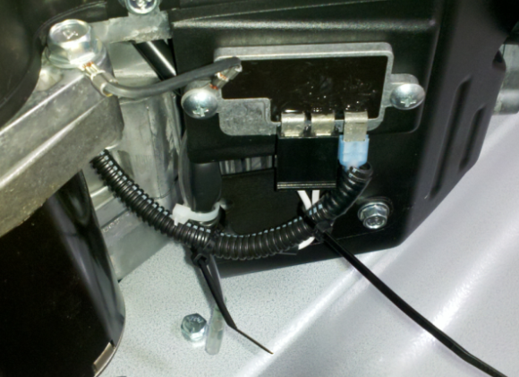
Attach to other wires from regulator
Attach to plastic cover

  - The large ring terminal with two black wires needs to be attached the the engine to provide the ground. This is done with a screw (81917) and a lock washer (81067).
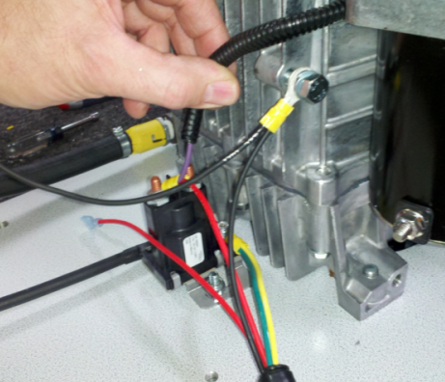

  - Use a red cable (12380) to connect the starter to the solenoid. Use a nut (83520) to fasten the cable to the starter. Use one of the nuts and a lock washer that was provided with the solenoid to attach the other end of the cable to it. Do not overtighten.
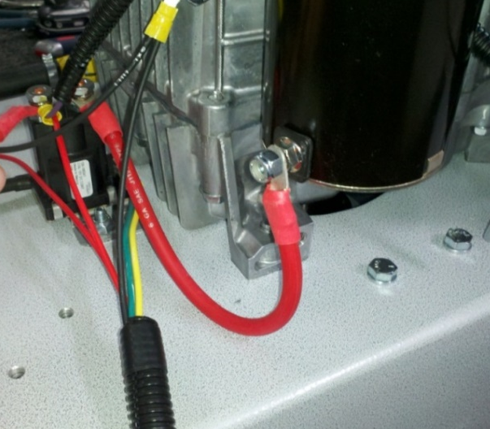

  - Connect another red cable (12380) to the other solenoid terminal. Let the cable sit in the orientation shown. Use one of the nuts and lock washers provided with the solenoid to connect this. Do not overtighten.
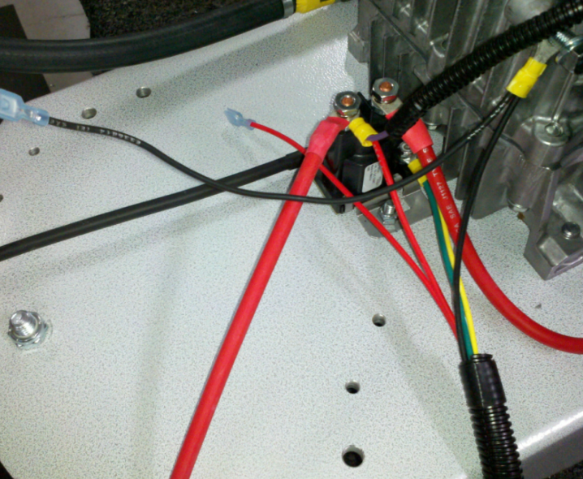

  - Connect the orange and yellow wires from the harness to the oil pressure switch. Orientation does not matter.
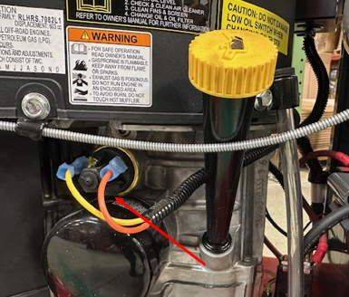

  - Connect the appropriate connector from the harness to the fuel shutoff.

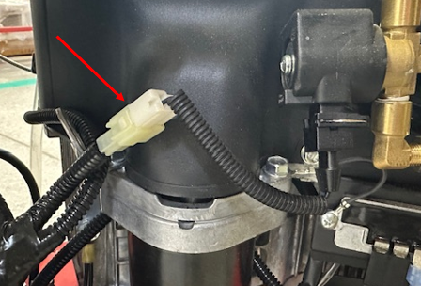

  - Get a battery that has already been load tested per SOP EQ 077.
  - Connect the black and red battery cables to the battery with a 10mm socket. These cables were connected to the solenoid earlier. Connect the wires as shown below. The hardware for this step is provided with the battery.

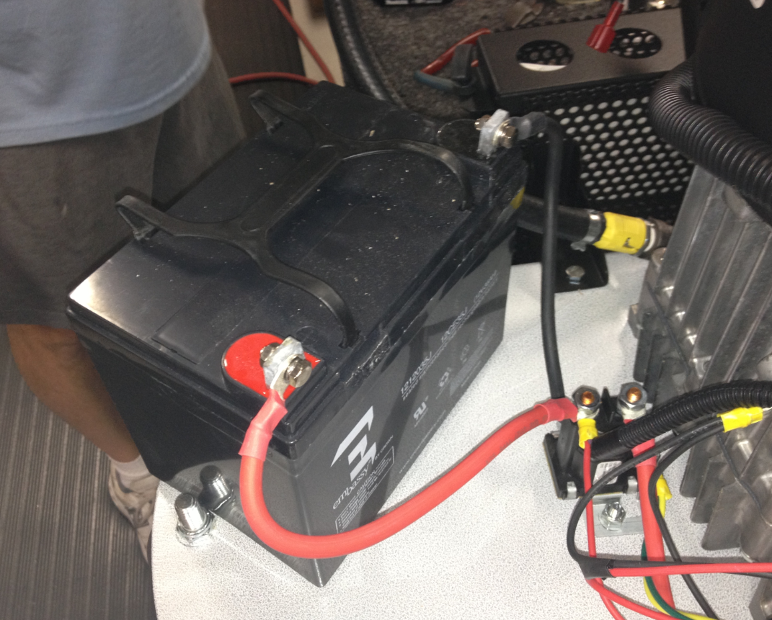

  - Get a right side handle upright that was assembled using SOP EQ 078. Attach the upright to the machine base using 2 bolts (83629), 2 flat washers (81062), and 2 nuts (11146). Only hand tighten the bolts at this point. Once everything is assembled, we will go back and tighten them.

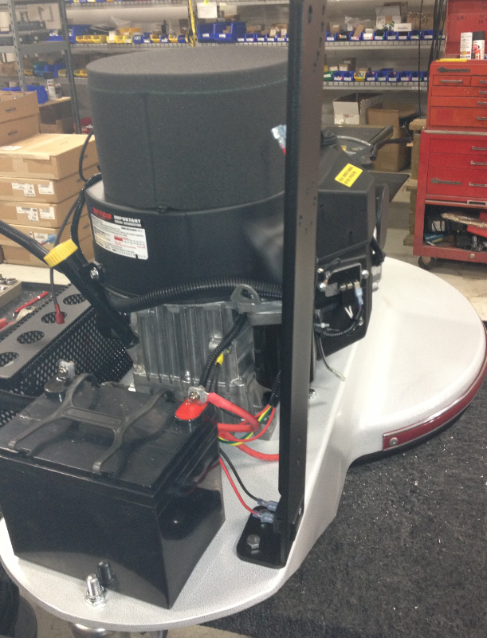

  - Connect the proper red and black wires from the wiring harness to the hour meter. It does not matter which wire goes to which side of the meter.

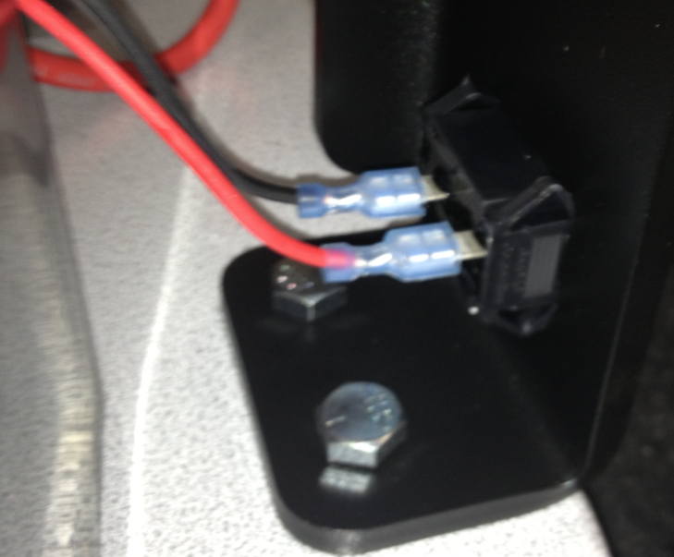

  - Attach the left side handle upright (89824) to the machine base using 2 bolts (83629), 2 flat washers (81062), and 2 nuts (11146). Only hand tighten the bolts at this point.

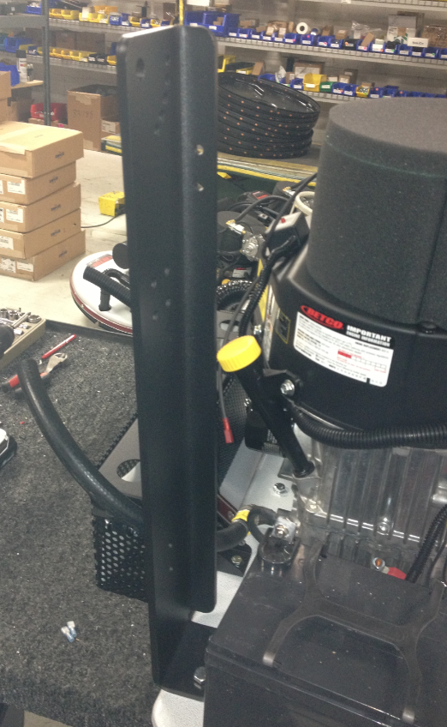

  - Take a battery clamp support (89822) with the tank pad (89823) stuck on top (Per SOP EQ 078) and place it over the top of the battery in the orientation shown. Ensure it sits snug on top of the battery. It will surround the battery on all four sides.

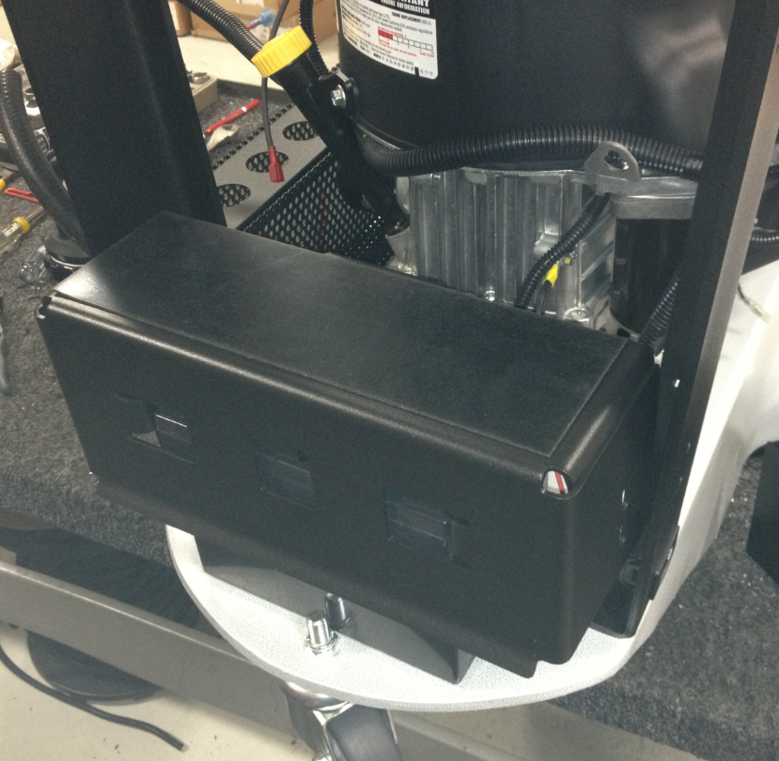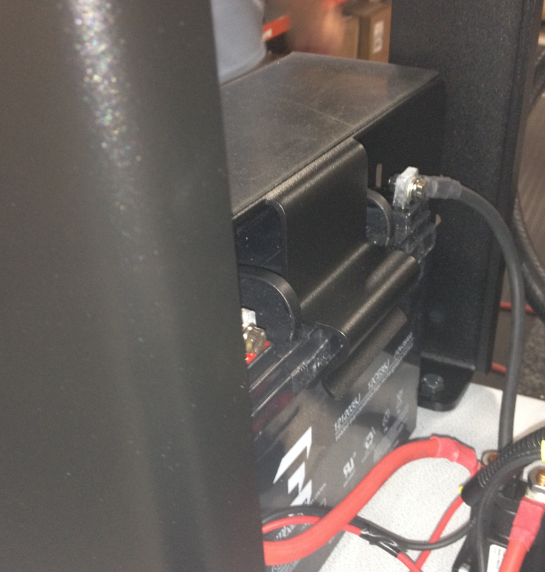

  - Place a battery cover (89826) around the back of the battery as shown.

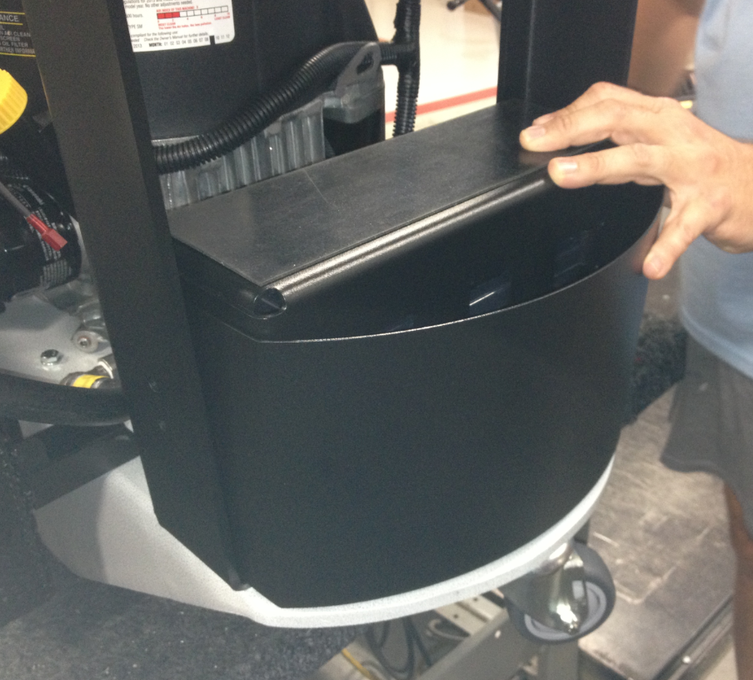

  - Line the holes in the handle uprights, the battery clamp support, and the battery cover up. Fasten them all together using 4 screws (81072) and 4 nuts (10141). Only hand tighten them at this point.

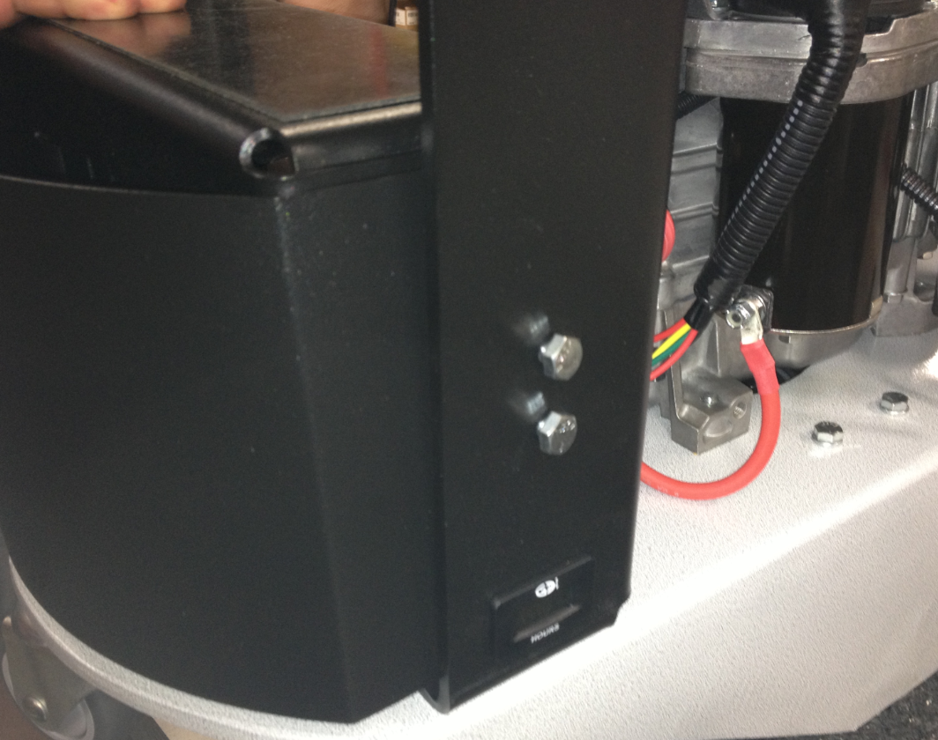

  - Take a front tank strap (88807) with the felt (10457) already attached (Per SOP EQ 078) and attach it to the uprights in the location shown. Use 4 bolts (81089) and 4 nuts (10141) for this step. Only hand tighten them at this point with a ½” socket. The strap will only go on in one orientation.

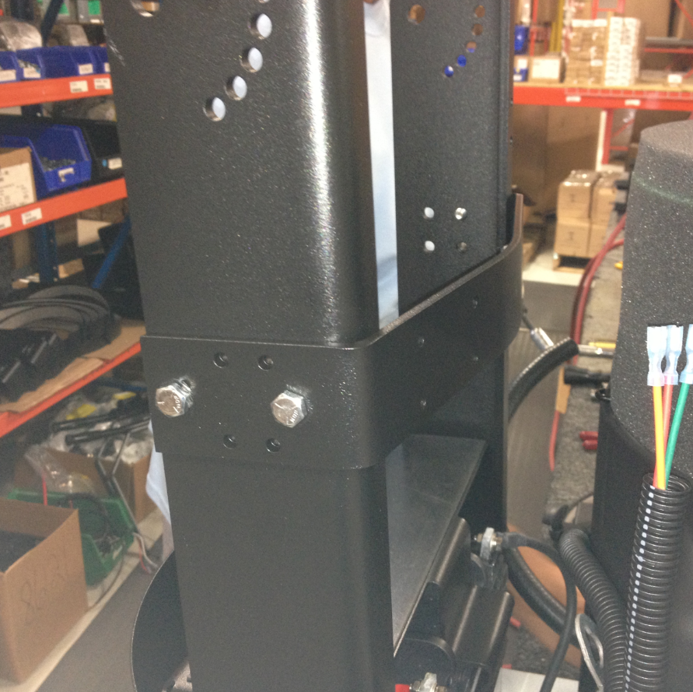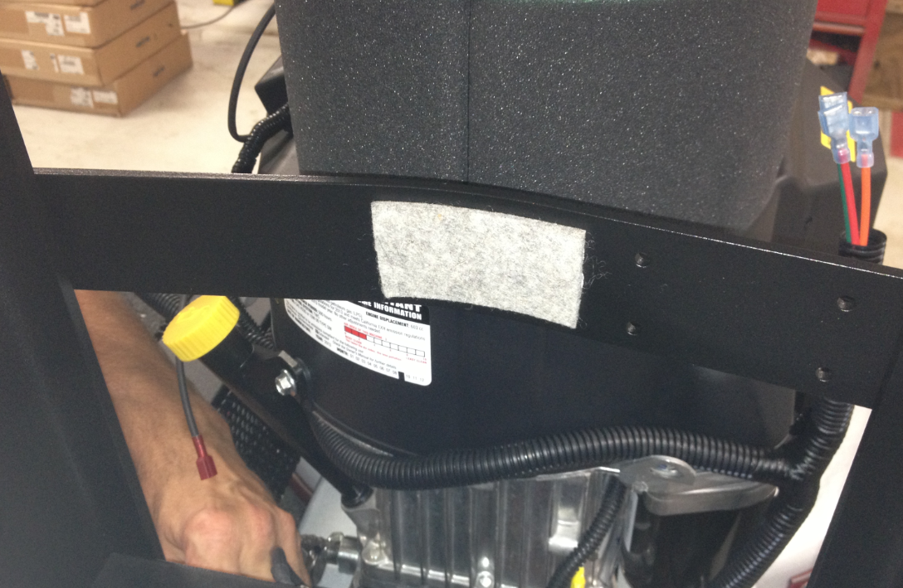

  - Bolt the back tank strap (86120) (Per SOP EQ 078) into the location shown. This step uses 2 bolts (81089) and 2 nuts (10141). The strap goes on the inside of the handle upright.

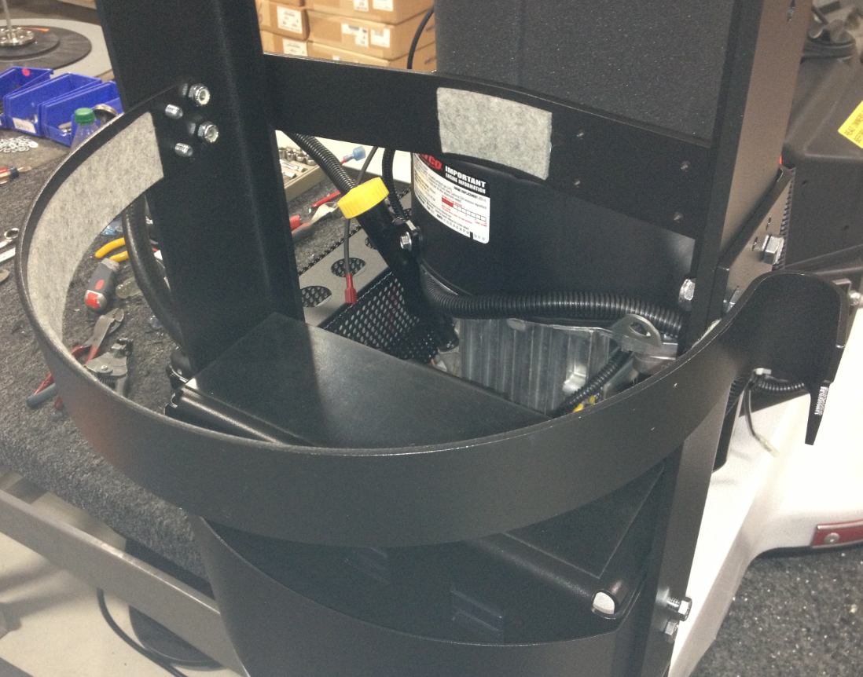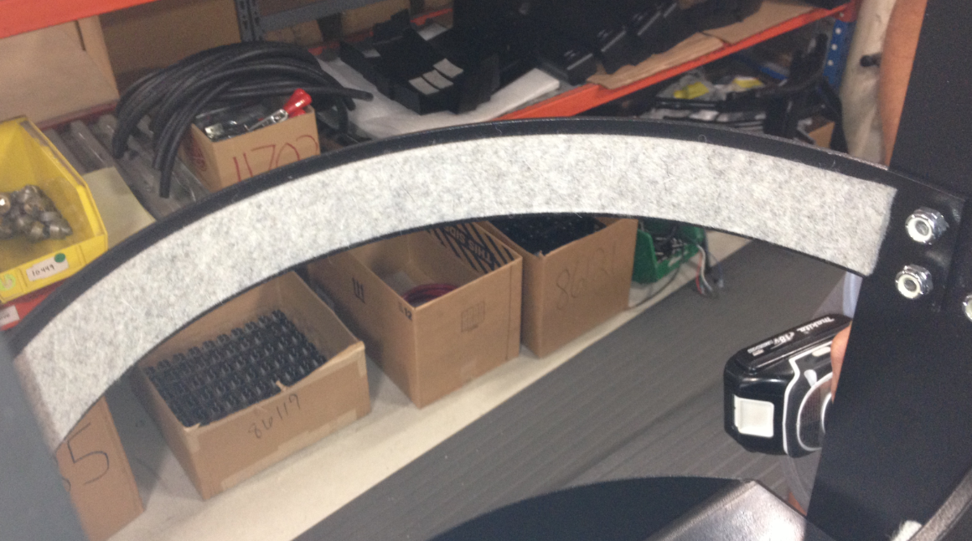

  - Go back now and tighten all of the screws that were used to assemble the handle.

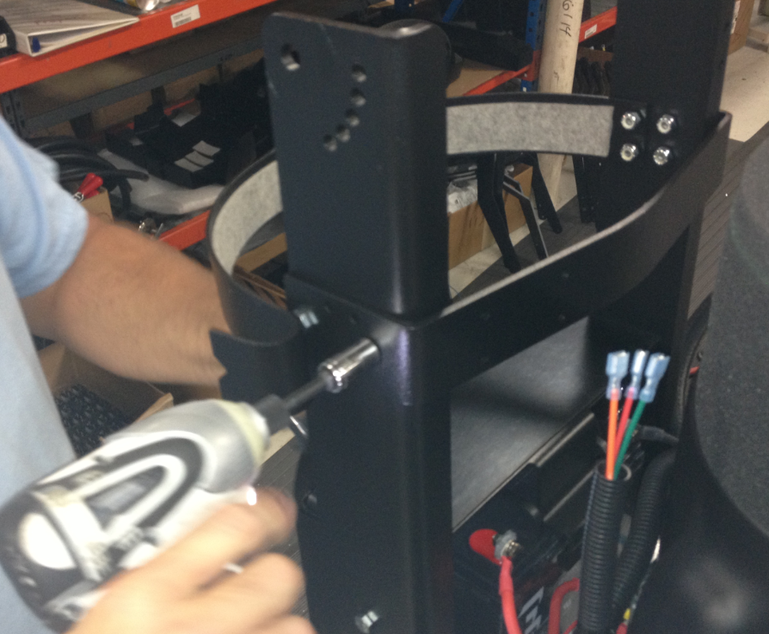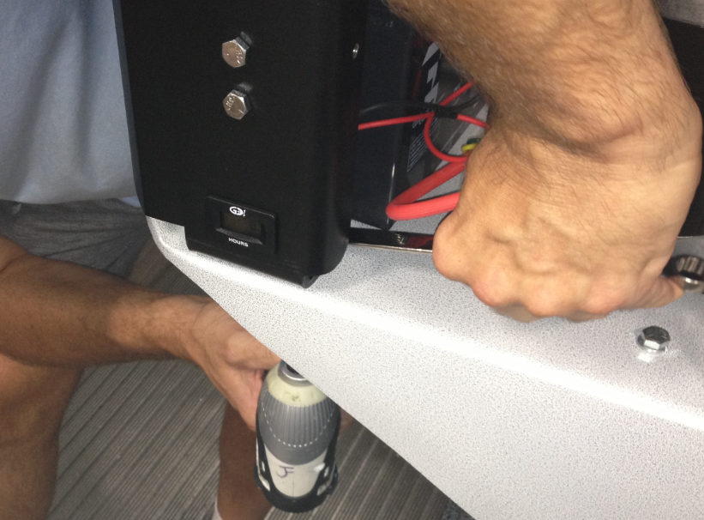

  - Get a handle weldment that already has the grips installed (Per SOP EQ 078).

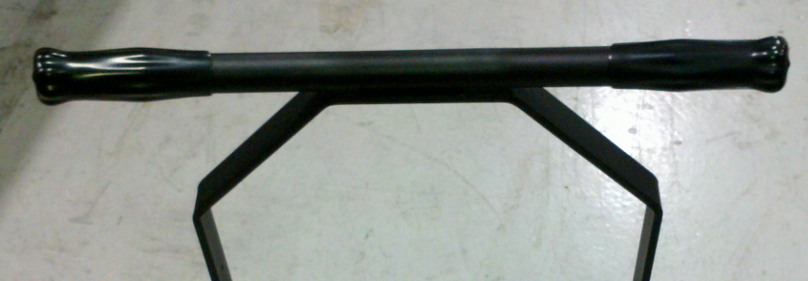

  - Attach the handle bar weldment to the lower handle assembly using (2) shoulder bolts (12476), (2) nylon washers (83145), and (2) nylon lock nuts (11146). The shoulder bolt will pass through the holes in the handle uprights and the handle bar weldment. There may be some paint buildup in the holes that could make this difficult. The nylon washer needs to be sandwiched between the uprights and the handle bar weldment. Tighten the nut until it becomes snug. There is no need to over tighten it here. Once each side has been bolted, rotate the handle bar back and forth a couple times to loosen it up and make sure that it rotates as it should.
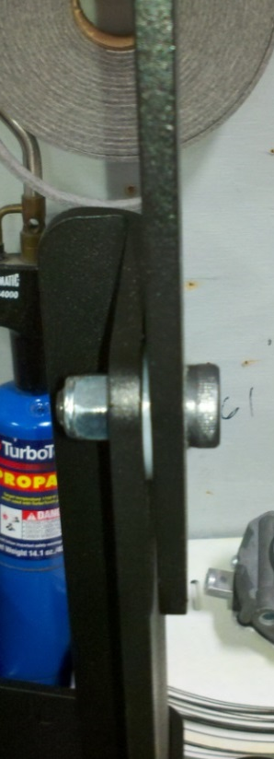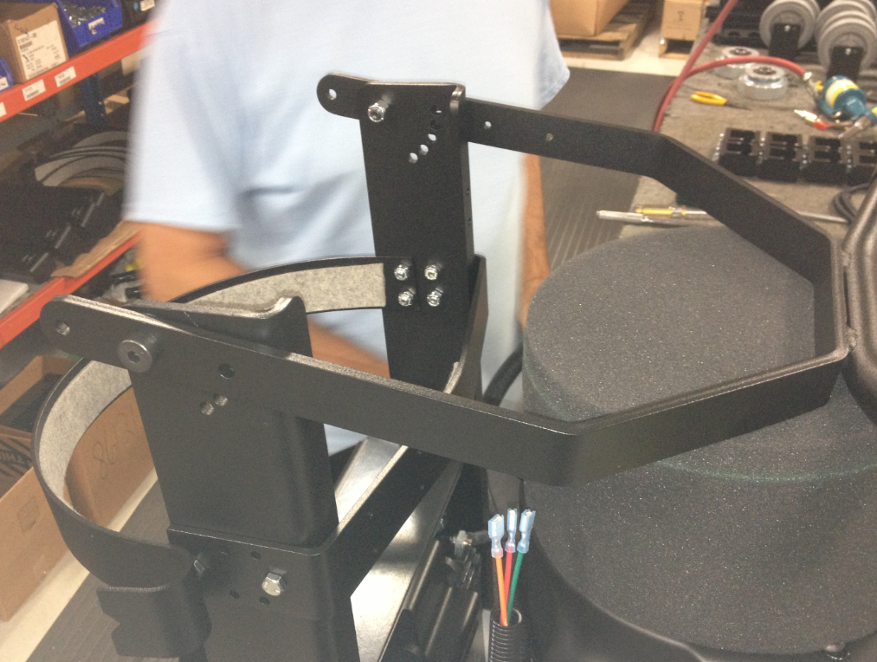
Shoulder Bolt
Nylon Washer
Nut
Handle Upright
Handle Bar Weldment

  - Insert 2 detent pins (87986) through the handle bar weldment and the uprights to set the handle height. There will be one on each side of the handle. This can be adjusted later as needed.

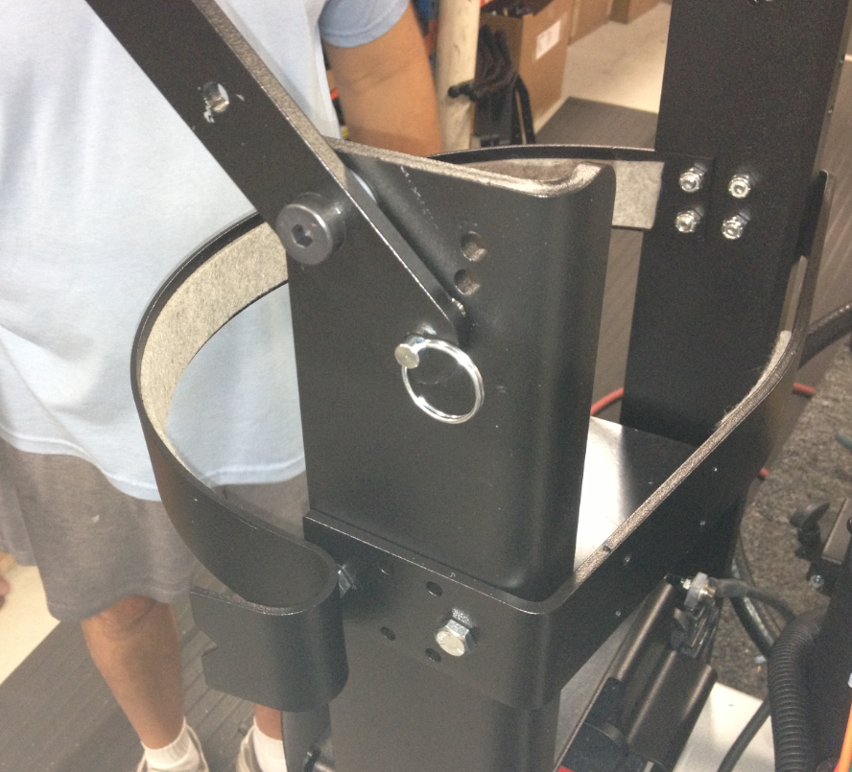

  - Bolt the clamp that was assembled in SOP EQ 078 to the handle assembly. This step requires 4 screws (86125) and 4 nuts (10120). Note the orientation of the clamp base.
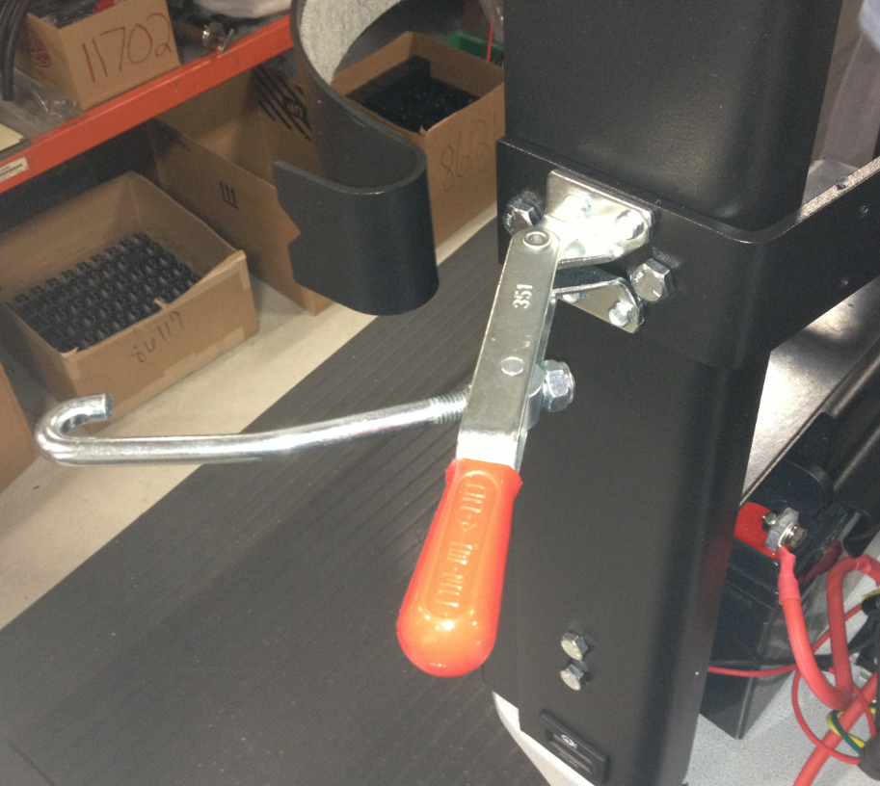
  - Take an assembled key switch box (SOP EQ 079) and pass the 3 wires for the key switch through the stabilizer clamp and into the body. Pull plenty of wire through at this point to allow work to be completed more easily.
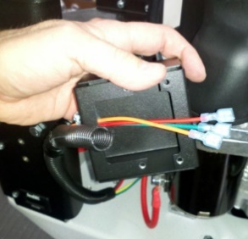

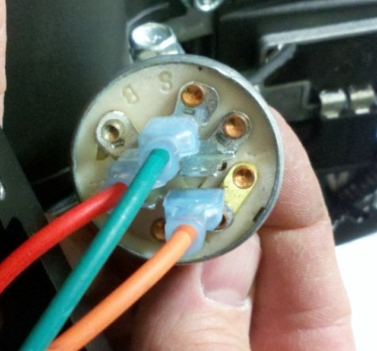
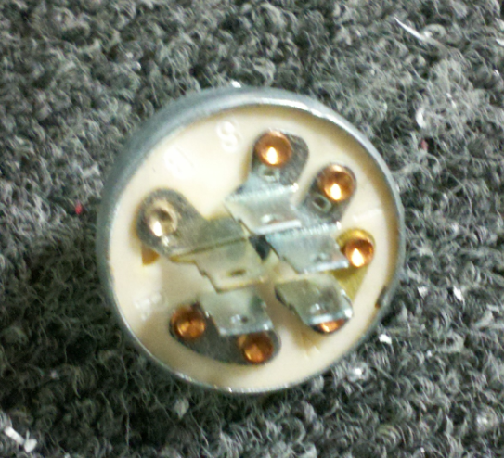
  - Take a key switch (E10449) and attach the key switch wires as shown. The green wire attaches to S, the red wire attaches to B, and the orange wire attaches to A.
B
A
S

  - Pass the key switch back into the box and put the threaded portion through the hole. There is a notch (or a keyway) on the key switch at the base of the threaded portion. This lines up with the tab in the hole in the box. Once everything is lined up, secure the key switch by tightening the nut that was supplied with it. Finally, put a key with the key switch.
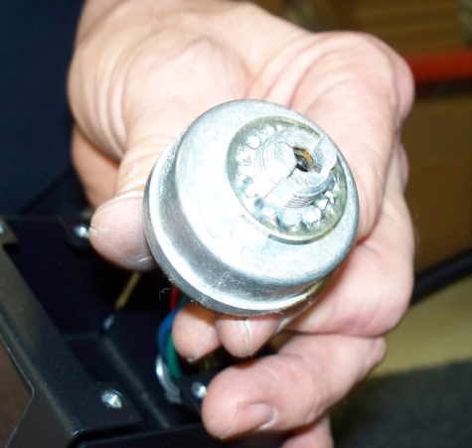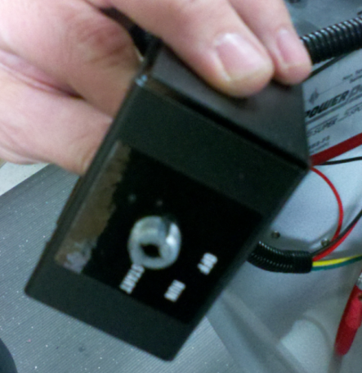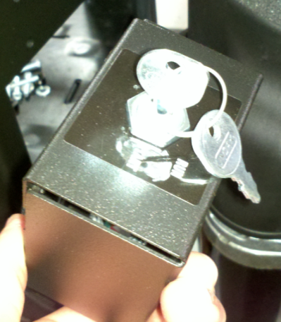
Notch
Nut
  - At this point, you will want to perform a test to verify that all wiring up to this point has been completed correctly and that there are no damaged parts. To do this, very quickly turn the key to the “Start” position and then immediately turn it back to “Off”. If the engine turns for that very short period, then everything is ok. If nothing happens, something is wrong. Find the issues and correct it. It is very important that you do not hold the key in the “Start” position! The engine will crank and it could throw that machine off of the table! You must simply “pulse” the engine.
  - Tuck the loom neatly up through the clamp. Once this is in place, tighten the 2 screws on the clamp to secure the wires.
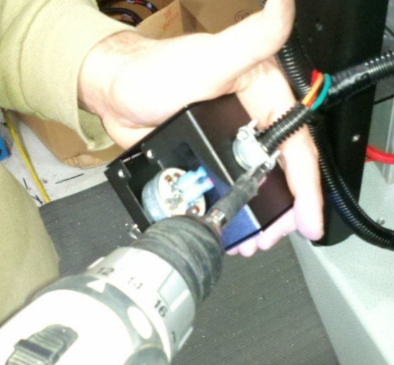

  - Bolt the key switch box to the tank strap using 4 bolts (86125) and an 8mm socket. Do not overtighten these bolts. You may need to run a tap through the holes first if there is paint buildup.
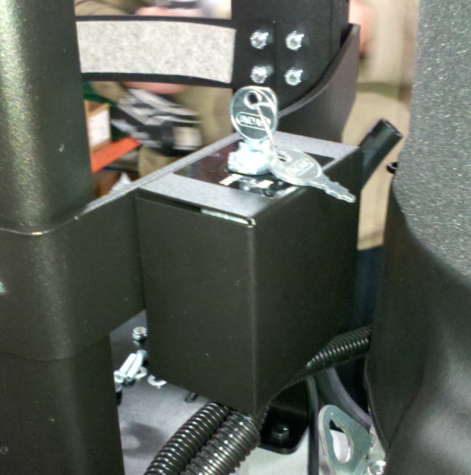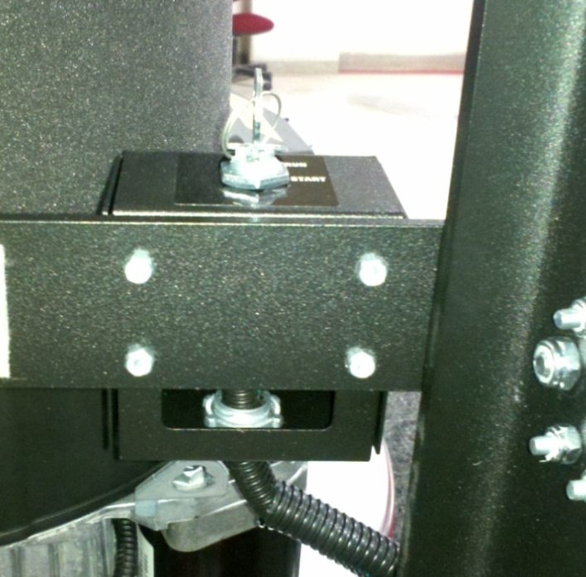
  - Take a throttle cable (86114) and insert the wire end into the hole on the throttle arm. Loosen the upper clamp and pass the cable through it.
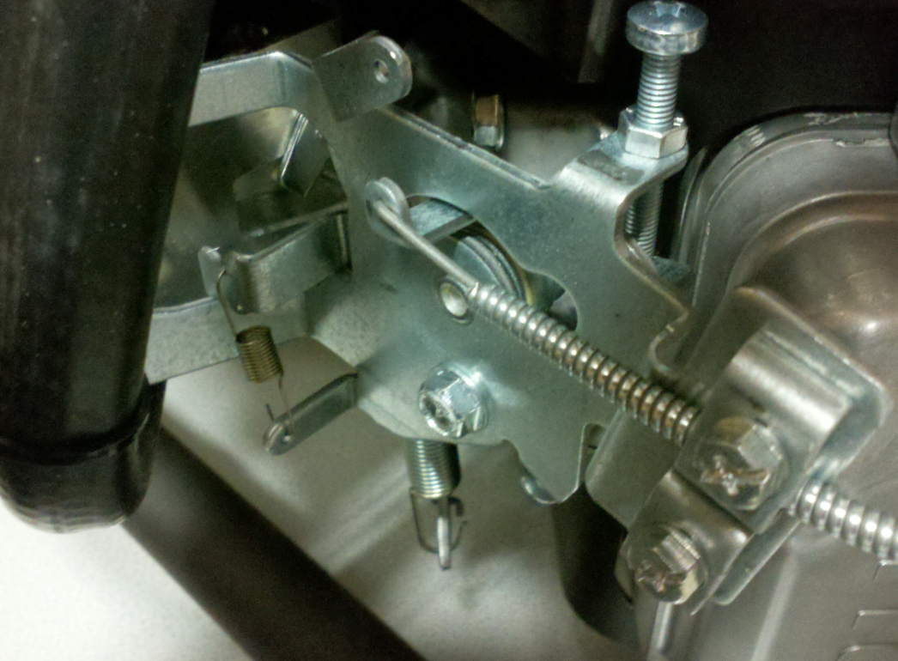
Throttle Arm
Throttle Cable
Upper Clamp

  - Fasten the lever portion of the throttle cable to the upper handle. Place 2 spacers (86228) between the throttle cable bracket and the handle in order to provide adequate room for the lever to move. Use 2 bolts (86125), 2 washers (11420), and 2 nuts (10120) to make the connection.
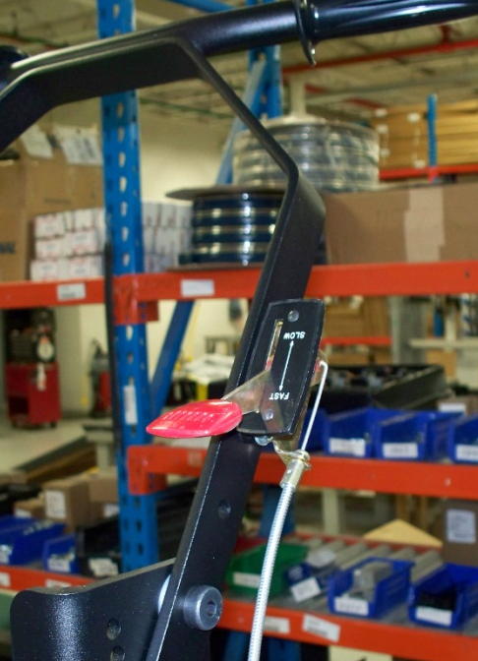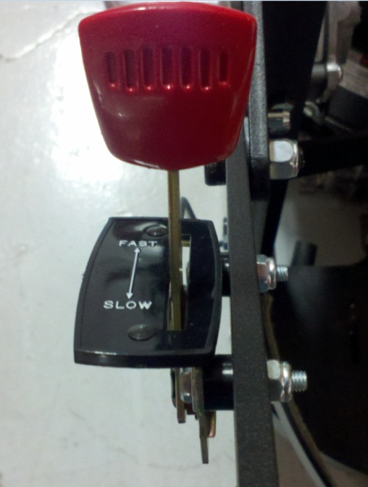
Spacer
  - Remove the existing bolt above the oil switch that holds on the plastic motor cover and install a tube clamp (10137) that contains the throttle cable. This will help hold the cable closer to the machine. Replace the bolt.
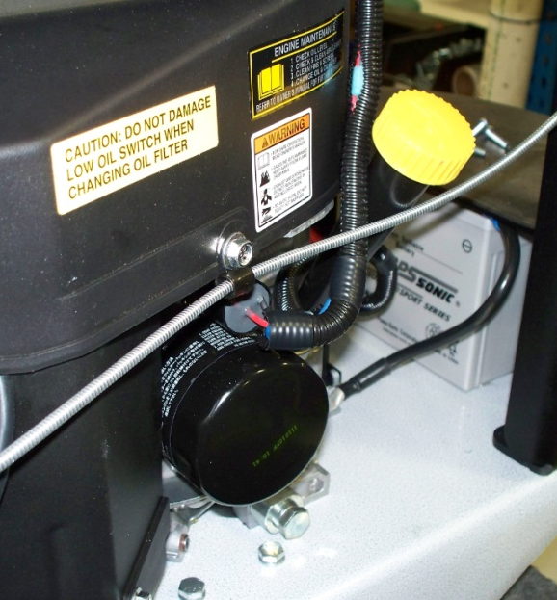

  - The throttle now needs to be set. Advance the lever to full throttle. Loosen the bolt that holds the clamp on the cable down at the linkage. Pull the throttle cable so that the throttle arm opens and the stop on it bottoms out on the limiter screw. Hold the cable there and tighten the clamp bolt. Move the throttle lever back and forth to make sure that everything moves properly.
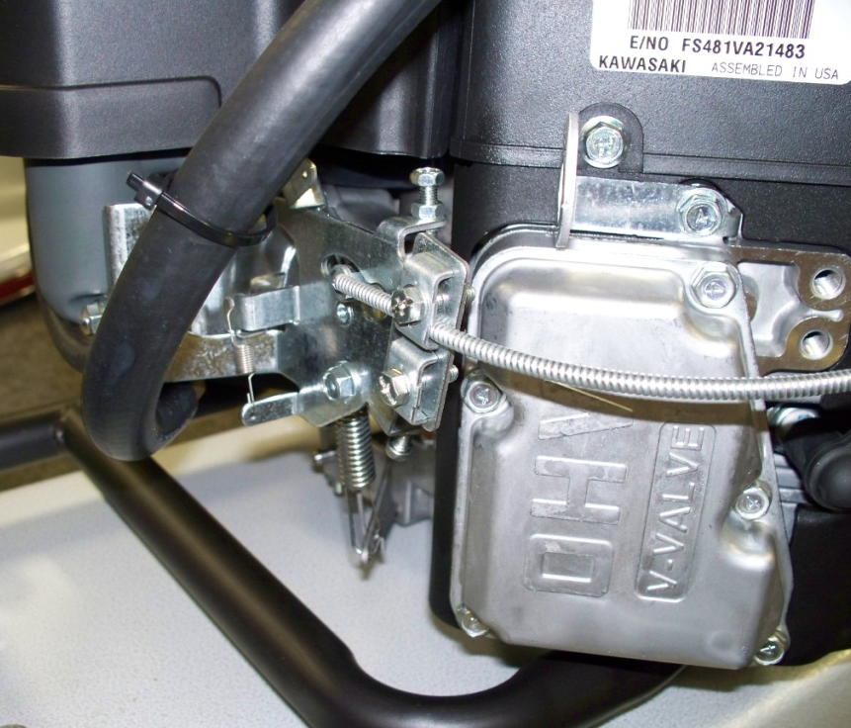
Pull cable this direction
Limiter Screw
Clamp
Throttle Arm

  - Add 1 ½ quarts of oil (10753) to the machine.
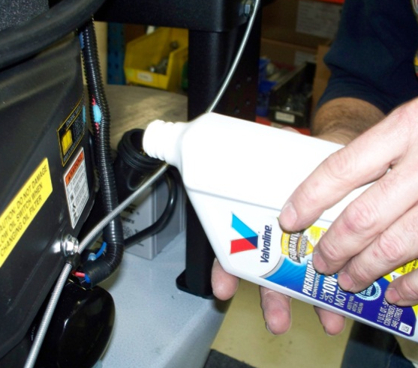

  - Place the machine decal (12982) on the front of the deck along with an “Xtended Run” decal (E12983) on each side in the approximate location shown.
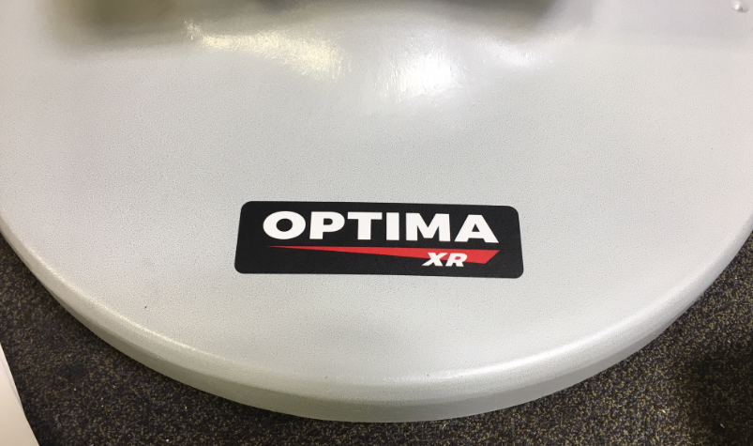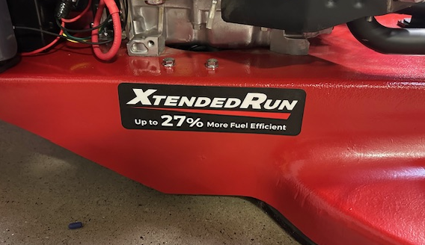

  - Stamp the serial number into the side of the machine. Fill in the letters with marker so they are visible. Use the logbook to find the appropriate number. In the log book, be sure that you record the last 5 digits of the motor serial number.
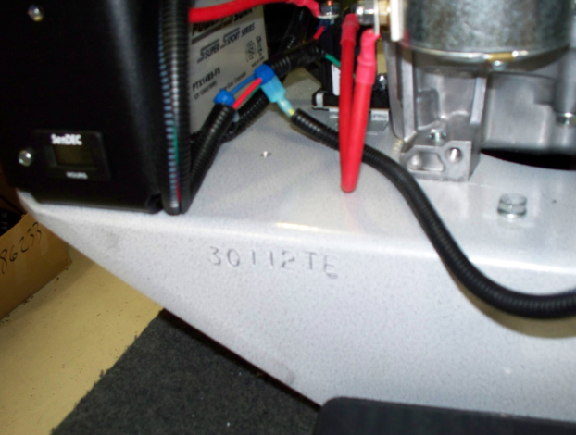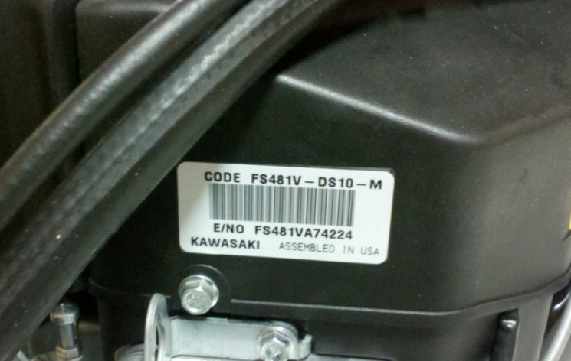
Record the last 5 digits
  - Take the machine off of the assembly table. Connect a propane tank. Start the machine and run it briefly. Verify that all function operate and sound good. Verify that the machine tracks in the appropriate direction. Make adjustments if necessary.

- References (optional section as needed)

- Training Guide

Functional Training Groups Requiring Training
Equipment Assembly Group

- SOP Change Control

Date of Change | Reason for Change
Rev 01 - 11/22/2013 | This is the first version of the S.O.P. hence there are no revisions to this document.
Rev 02 - 1/15/2018 | Added the responsibilities section and took out the grinding steps required for the 21” machine with clutch.
Rev 03 - 5/4/2018 | Update for the Optima XR launch
Rev 04 - 4/24/2020 | Corrected terminal naming on keyswitch
Rev 05 - 3/21/2025 | Removed steps for Onyx engine and removed work center notes. Also update machine ID list in Scope 2.01

Approvals
Submitter/Author Approval:__________________________________ Date:______________________

Management Approval:______________________________________ Date:______________________

QAU Approval:_____________________________________________ Date:______________________

